**My language portfolio**

|  |
| --- |
| **Name:  Zulgy Dambieva**  **School: gymnasium 33**        Class:  8 V |
|  |

                                      I.  Language Biography

**All About Me!**

Name: Zulgy                                                             Date of birth: 29/01/2001

Age: 14 y.o                                                              Place of birth: Ulan-Ude

I am in my 7 year of English

My English teacher`s name: Balzhirova Marina Vasilyevna

**Read and put a tick or a cross.**

Some members of my family speak English. Yes

Some members of my family are from an English-speaking country. Yes

I often read English books, magazines, etc. Yes

I often watch English TV programmers. No

I often listen to English songs. Yes

I have extra English lessons. Yes

There is someone at home who speaks English to me. Yes

I have contact with people from English-speaking countries. My sister

I have visited/lived in the following English-speaking cоuntries. No

My Lake Baikal Box

1. Baikal’s Birthday…………………………………………………………………
2. Baikal waves……………………………………………………………………..
3. The Baikal Seal………………………………………………………………….
4. SOS! Fire........................................................................................................
5. Native scientists…………………………………………………………………

**Baikal’s Birthday**

The age of Lake Baikal is of great interest to scientists, who now believe that the Lake is about 20-25 million years old. It is a very ancient lake. Other lakes live for about 15,000 years, before they disappear, but Baikal is still young – its area and its depth are still increasing, and the opposite shorelines are moving apart at a rate of 2 cm per year.

The ecologists of Baikal region recently decided that our Lake deserves a birthday: every year since 1999, we celebrate Baikal Day on September.

**Baikal waves**

How are waves made? They are created by the influence of wind, tides, earthquakes, vessels moving on the water, and other external factors.

The waves on Baikal can be up to 4m high, depending on the wind speed, duration on its action, and the distance over which the wind drives the waves.

Waves on Baikal are caused by the various winds, which blow across the Lake.

When the wind blows at a speed of less than 1m per second, the waves that emerge on the still surface of are no more than ripples. If the wind blows at 4-5 m per second the waves grow larger and more visible. Large waves with foaming tops are called breakers. If wind speed reaches 7-8 m white horses appear on the wave crests: these are air bubles formed when the wave crests roll over.

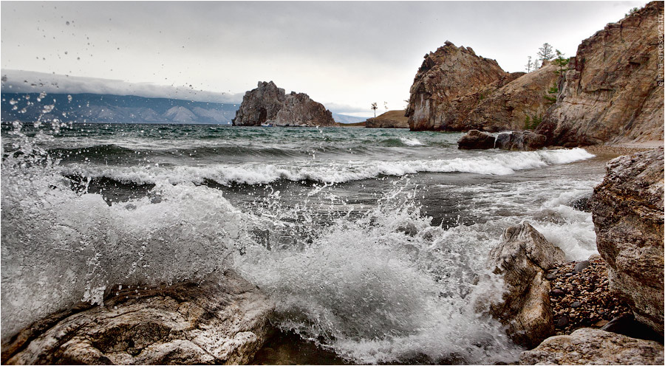

**Baikal seal (nerpa)**

The nerpa is a large mammal: adults are over 150 cm long and can weigh up to 110 kg. It is endemic to Baikal and is the only mammal living in the Lake. The nerpa is a member of the true seals family and a part on the Pusa genus. The back of an adult nerpa is silver – gray and its belly is light with a yellowish hue.

The female nerpa can live for 56 years and males may live 52 years, and child- bearing age for the female is from 4-7 to 40 years, in which period she can produce over 20 offspring. One pregnancy lasts for 11 month and produces one seal pup.

Baikal seals eat fish, particularly gobies, and are also partial to the most numerous fish in Baikal – the oil fish.

Locals have several names for the nerpa: «ushkan», «kumutkan», and «hubinok». A new born baby seal is called a «belyok», and it has become one of the best – known symbols of Lake Baikal.

A seal – is a very cautions and timid animal. To see it in nature is a very difficult. In order to watch it and to study this unique mammal, a lot of house – houses were organized on Baikal.

There one can see trained seals which can sing, dance, paint, play with a ball. Animal – trainers say that it is quite difficult to work with seals, because they are very independent animals.

The most important task of creating seal – houses is study and preservation of this Baikal endemic, one of the three species of freshwater seals.

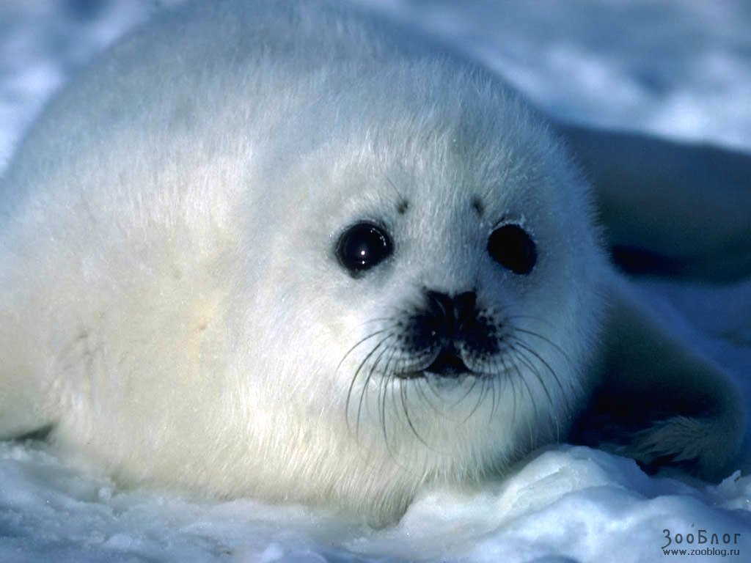

**SOS! Fire!**

The greatest threat to the forest around Baikal is from fires, which are particularly destructive for coniferous forest, since it takes longer to restore.

Fires are usually caused by people who fail to put out a camp fire or throw down a burning match or cigarette. Very rarely fires are started by lightning.

Fire destroys the habitat of birds and its aftermath is a «green desert» of deforested land covered by shrubs and grass. Until the taiga is restored, only poor – quality species of woods will grow. What would happen if the Lake did not have forests around it? Rains water would wash earth down into the Lake in a dirty avalanche, the rivers and streams feeding the lake would dry up, and Baikal would turn into a big, dirty reservoir.

**Native scientists**

**Gleb Yurevich Vereschagin** (1889 – 1944) was one of the founders of limnology, which is the science of lakes. Vereschagin came to Baikal for the first time in 1916, and devoted the rest of his life to its study.

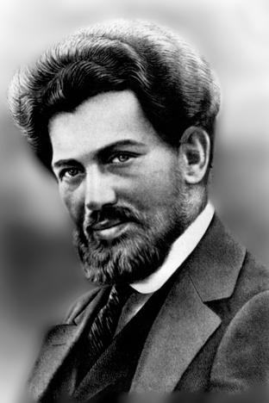

**Mikhail Mikhailovich** Kozhov (1890 – 1968) was an outstanding Siberian scholar and creator of the specific discipline called «Baikal studies». Kozhov carried out studies of sponges, epischura, lop – eared maxillopids, bullheads, Baikal oilfish and other fauna.

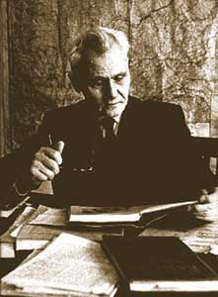

**Grigory Ivanovich Galaziy** (1922 – 2000) was an academician, doctor of biology, and the author of more than 400 works and 8 monographs on Baikal. Working at the Limnological institute of the Siberian Branch of the Academy of Science of the USSR, Galazy set up a research station on Baikal, which he headed for 26 years.

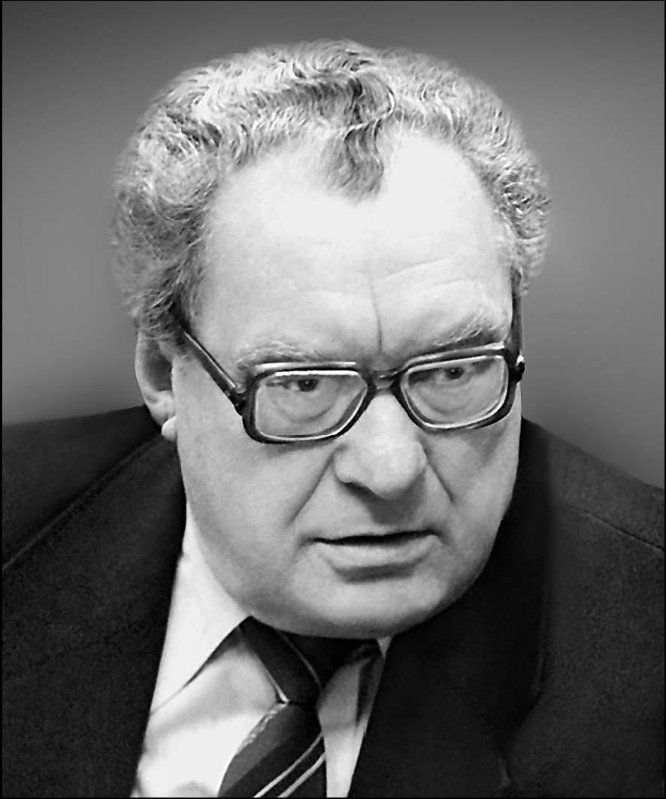

Guess the animal species:

